**Equipment Information Form**

Purpose: This form is the single most important form with respect to collecting equipment information. The idea is that in the eTool only the most recent data about a piece of equipment would be shown at any given time. Therefore, in addition to capturing data on new equipment, this form can also be used if a piece of equipment was moved. However, the weakness of this form is that if for example the equipment moved from lab A to lab B, then not only would the user have to change the value for the lab location but they would also need access to the eTool in order to put the correct value for all the *other* columns. So unless we were to make a separate form to correct each field, we would have to reenter the values as described.

Additionally, many of the fields are drop downs, restricting the choices to just the options shown in the dropdown. This prevents users from making mistakes during data entry (capital letters, typos, etc). However, this also requires that whoever puts the form together knows all the possible choice that users will want. If the choice the user wants to make does not exist, someone will have to be alerted they need to change the available choices.

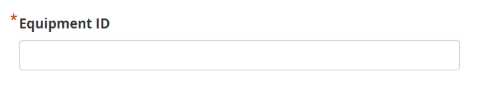

Free entry field stored as text. While the ID could be a number, it is likely any serial number also has numbers.

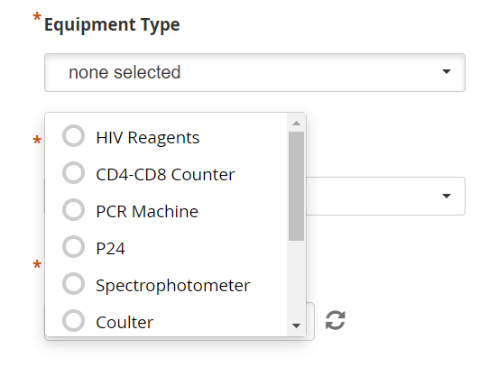

Dropdown responses (not all choices shown). Equipment types selected based on a list provided by IRESSEF.

*I would need additional choices if appropriate.*

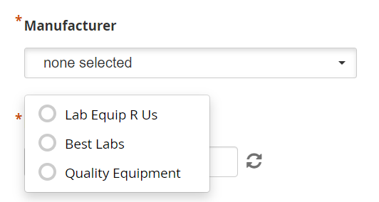

Dropdown responses to collect the name of the equipment manufacturer.

*I need a list of possible or actual manufactures as those shown above were just made up for demonstration purposes.*

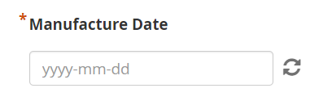

Entered using a calendar dropdown. Required field. Could change to optional if we find this is something that is often unknown. However, some of the alert logic in the eTool is structured around the manufacture date.

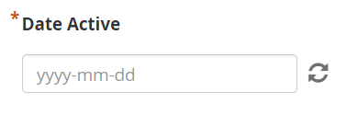

First date the equipment was used in the lab.

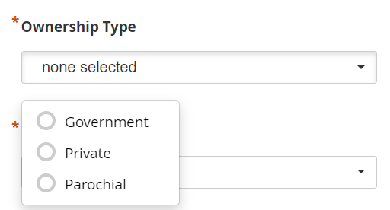

Dropdown options selected with assistance from past collaborators. Could change the field title to donation type? The idea was to capture the funding mechanism for the equipment.

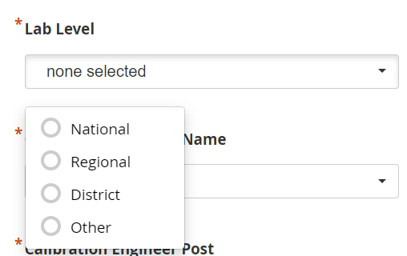

Also selected with the help of past collaborators.

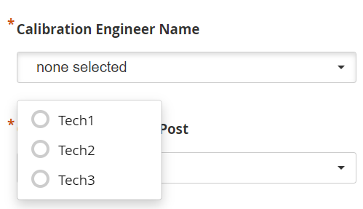

Selects the technician’s name from the dropdown. Would need a list of technician names. Logic is built into the eTool to send alerts to the correct technician. However, we may just want to base this logic on the company providing the service.

*I would need a list of technicians to add to this.*

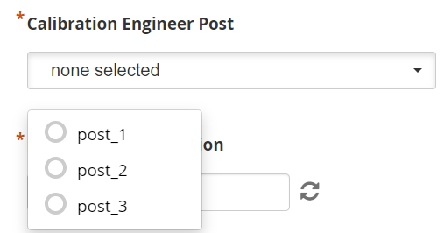

Dropdowns for the names of the companies providing calibration services.

*I would need a full list of service providers.*

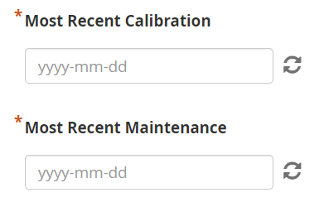

Dates of most recent calibration or maintenance.

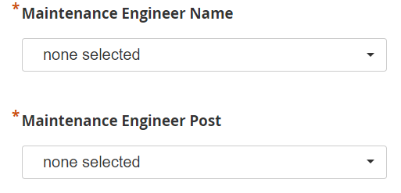

Same as above except for maintenance activities.

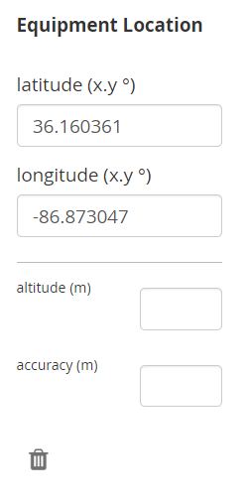

Optional entry for latitude longitude if known.